Filtering data with AND, OR, and NOT

**Introduction**

As a security analyst I utilized SQL to get information on employees, machines, and departments they work in.

For this I used MariaDB shell to run these queries with filters.

**Objectives**

1. Filter for login attempts that occurred after hours
2. Filter for login attempts on specific dates
3. Filter for login attempts from specific locations
4. Filter for information on employees in specific departments
5. Filter for information on employees not in a specific department

**Filter for login attempts that occurred after hours**

For this task I made queries in SQL to filter for failed login attempts outside of business operating hours.

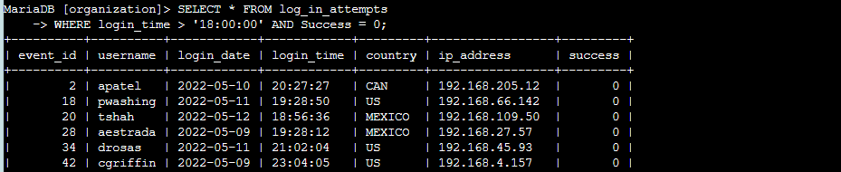

**Filter for login attempts on specific dates**

For this query my team and I were looking at failed login attempts in relation to an incident that took place on ‘2022-05-09’.

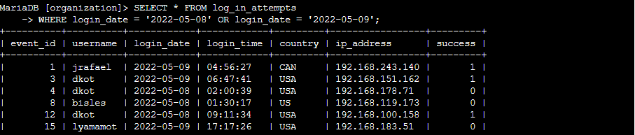

**Filter for login attempts from specific locations**

For this query I filtered for login attempts that did not originate in Mexico.

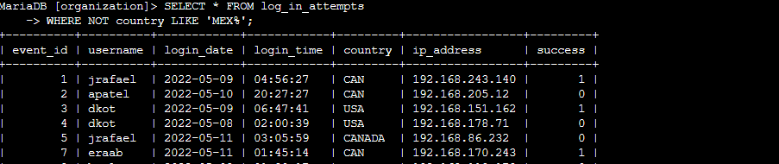

**Filter for information on employees in specific departments**

For this task I ran a query that searched for employees in the marketing department located in the East side of the building so we could update their machines.

**Filter for information on employees in specific departments**

My plan was to locate all employees in the sales or finance department and update their computers, which I used the OR operator to filter through relevant departments.

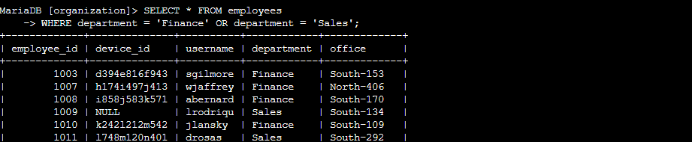

**Filter for information on employees not in a specific department**

The plan for the team and myself was to find employees not in the IT department and update their machines, so I used the NOT operator to extract the relevant information quickly.

